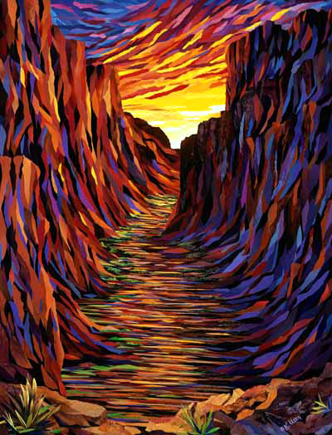

FOrm your landscape
Riley Giles

Lesson Plan (ART 265)

Student Teacher: Riley Giles
Title of Lesson: TransFORM your landscape
Big Idea: Nature
Social Issues: / Concepts of the Lesson / Essential Questions:
- What are seasons?
- How can we represent form in art?
- What season is it now?
- What did it look like outside?
- How can you incorporate colors to show seasons?
List of Concepts of Art, Artists, and Culture Involved in this Lesson:
- Color, shape, and form
- Kathrine Uster
- Rachel Perryman
List of Teaching Resources:
- Visual board
- Printed images of simple time-of-season landscapes
- 10x13 inch cardboard sheets
- Construction paper of various colors
- Scissors
- Glue
- Pencil
- Video link: https://www.youtube.com/watch?v=b25g4nZTHvM
- Video will be downloaded onto flash drive as backup
- I Love to Collage, Jennifer Lipsey (2006)
- Art of Kathrine Uster and Rachel Perryman
Class Information
Grade Level(s): 3rd
Number of students: Unknown
Time available for this lesson: 70 Minutes
Class Location: CAC room 2514
Teaching dates: October 29th
1. Objectives:
1.1 Conceptual/Cognitive Objectives:
OBJECTIVE I: Given a video on seasonal changes, students will be able to identify all four seasons.
OBJECTIVE II: Given a discussion on the book I Love to Collage, students will understand how art can be used to depict an abstraction of the seasons.
OBJECTIVE III: Given definitions of vocabulary words, students will understand Shape and Form.
1.2 Artistic Skill Objectives:
OBJECTIVE IV: Given a demonstration on stenciling, students will understand how to use stencils correctly.
OBJECTIVE V: Given glue, cardboard, and printed photos of nature students will cut out their traced shapes and paste them onto their cardboard in a way that forms a composition.
OBJECTIVE VI: Given examples of artists nature collage pieces, students will create a full composition that uses forms from nature.
2. Assessment Criteria:
OBJECTIVE I: Students are able to recall at least two artists from the list that have used collage to create landscapes.
OBJECTIVE II: Students show an understanding of each season and why they change.
OBJECTIVE III: Students took creative lead with their project by displaying their own technique.
OBJECTIVE IV: Students display a good standard of craftsmanship
OBJECTIVE V: Students overall composition is well thought out and somewhat relevant to their photo reference.
OBJECTIVE VI: Students have achieved a composition that is finished and readable.

3. Learner Characteristics:
3.1 This lesson is appropriate for Third Graders because it uses paper collage, which requires little skill, yet still yields aesthetically pleasing results. This is appropriate for this age group because, generally, they haven’t acquired high skill levels but desire to create something pleasing and something they are proud of. This lesson integrates science, which is a great way to get students who may not be “into” art, excited to learn and do art.
3.2 This lesson could be easily adapted for students with special needs. For students who have physical disabilities, tearing paper to collage is great. One of the artists, Kathryn Uster, was in a car accident during her time in college and lost much motor control due to a head injury. She developed the technique she uses in the lessons example piece during her time with this disability. Students who have cognitive disabilities may be assisted by the teacher and/or given a copy of the directions stated quite clearly with pictures and alternative processes.

4. Literature and References
4.1 Rationale of this lesson
Throughout the young life of an artist, there is often a biased look at what makes good art. Generally, these views are that if someone cannot create realistic art or do not create realistic art, they are not a(n) “good” artist. Even when Picasso’s work is discussed, it is often followed by how well developed his realistic skills were despite his abstractions being incredible by themselves. Young artists are often pressured to create photorealistic pieces in order to achieve greatness and the approval of others. Due to this, many aspiring artists do not continue on their path of creativity. Instead, they dismiss their underdeveloped skills as being a bad artist and lose their passion to do better.
This lesson is designed to inform students of seasonal changes, the differences between form and shape and finally, to show students that no matter their skill level, artwork is appreciated and encouraged. Students will be able to be creative and adventurous and not feel pressure to create what they feel others want to see, but rather, what they, themselves see.
4.2 Background of the topic
"'Abstraction' in its many forms has been a dominant presence in art for the best part of a century. Yet despite being the subject of countless exhibitions and a central focus of critical debate and of art historical investigation, abstract art continues to perplex many viewers." Gooding, M. (pg.20). Despite being such a prominent movement in Art History, abstraction seems to be the most underestimated and most disregarded style for young artists. “… there was a tendency over time for artists to produce their most valuable work-and the work that art historians have judged their most important-at progressively younger ages.” Galenson, D. (pg.33). Students have many important artistic phases during their young lives. Often times these phases are claimed to be progress in creating perfect proportions and photorealistic pieces, but abstraction offers so much to a young artist. It offers a good platform for expression without limitation or expectation, creative control, and a better understanding of their perceptions.
4.3 Information about related artists, styles, movement or cultures
Kathryn Uster was raised in Connecticut in the Berkshire Mountains. As a young girl she was encouraged to create art by her father and majored in ART in High School. She continued her education in Art throughout college and often took inspiration from the natural world and depicted the landscapes she saw. With a goal of conservation, Uster used recycled or used paper products to create her pieces and continues to do so today.
Rachel Perryman is an aspiring artist who uses collage to depict outdoor scenery and object from nature such as flowers, leaves, ferns, and animals. Perryman uses much mixed media in her art, primarily paint and paper collage. Currently a school teacher, Perryman hopes to gain enough recognition to become a full-time artist and make a living doing so.
4.4 Art Terms/Vocabulary Define each fully
Composition- formation of a whole by placing things together
Foreground- Portion on composition nearest to the viewer.
Middleground- Portion of composition between foreground and background
Background- Portion of composition furthest away from viewer
Shape- External form or appearance of a subject, the outline
Form- visible shape or configuration of something
4.5 Description of visual examples
- Kathryn Uster
- Kathryn Uster, Canyon Morn
- Rachel Perryman, Four Seasons
- Visual board back, then front

- Student work
4.6 List of references
Gooding, M. (2001). Abstract art (Movements in modern art). Cambridge, U.K.: Cambridge University Press.
Galenson, D. (2001). Painting outside the lines : Patterns of creativity in modern art. Cambridge, Mass.: Harvard University Press. (2001). Retrieved November 25, 2018, from https://ebookcentral.proquest.com/lib/wvu/detail.action?docID=3300810

5. Integration/Connecting Links
5.1 Idea mapping
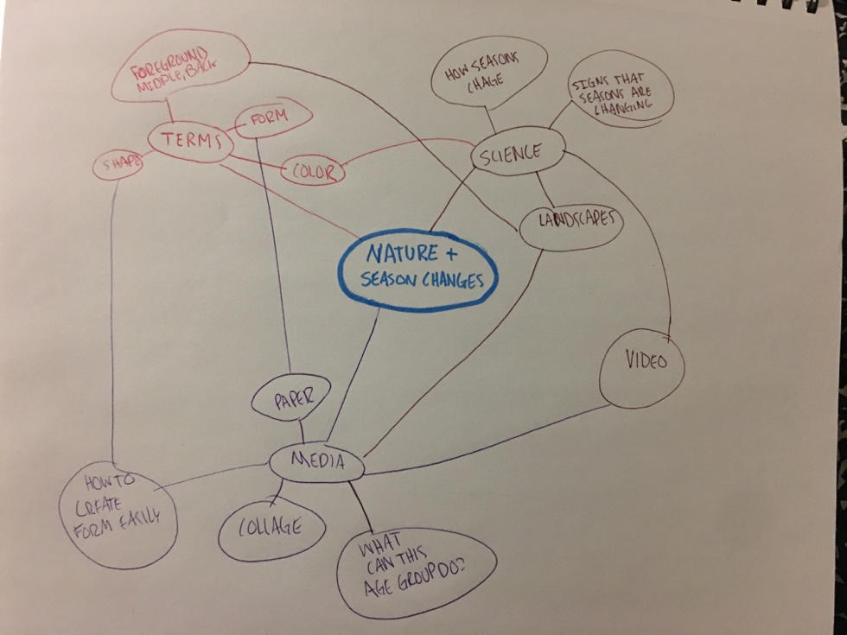
5.2 Daily/Ordinary objects
Leaves, sticks, recycled papers, images of all four seasons.
5.4 Poetry/Story/Myth/Tale/Literature
of techniques and outcomes of collaging. This will help auditory, visual, and reading learners simultaneously.
5.5 Non-art related subject areas (optional)

I will use the video Seasons and the Sun: Crash Course Kids 11.1 to help students understand on a scientific level, the reasons for the seasons. This will help students visualize each season and the aspects their selected season may have.

6. Looking at and talking about ART
6.1What kinds of colors do you see in this piece? Does it indicate what season it is?
6.2 What do you think the piece is made of?
6.3 Why do you think the artist made this piece?
6.4 What do you think the artist is trying to portray?
6.5 Is there a focal point?
7. National Goals
Goal # 1 Media Techniques and Processes
VA.S.3.1
In this lesson: Students will compare how different techniques and processes in collage create different qualities and appearances.
Goal # 2
VA.S.3.2
In this lesson: Students will identify selected elements and principles of design as they relate back to the environment by identifying underlying shapes that create forms in nature.
8. Media/Art Materials Needed and Organization of Supplies
8.1 Day One:
One of each following item will be placed on students desk before arrival to class:
- Printed images of simple time-of-season landscapes, two different images for each season
- 10x13 inch cardboard sheets
- Construction paper of various colors (preferably recycled)
- Scissors
- Glue, stick and liquid for student preference
- Pencil

9. Instructional Procedure with Time Frame
9.1 Day One
Students will learn about why seasons change and create collages based off of their chosen season.
Today we will be using shape and color to imply form and create a composition of a landscape using collage.

9.1 Day One
- Dialogue:
- Teacher: Welcome, class, take a seat and we will begin with our lesson for today. *allows students to sit and begins with introducing the artists and their work*
- Is anyone familiar with Kathryn Uster or Racheal Perryman? *wait for yes or no answers, then introduces artists with background info and details of their artwork. Teacher shows Kathryn Uster’s Canyon Morn and Rachel Perryman’s The Four Seasons.*
- Can anyone tell me what they see in these pieces? How do you think it was made? What are the artists trying to show? *allows small discussion* (topic questions)
- *shows video*
- Please pick a scene from the photos on your desks.
- (Transition to demo)

9.1.1 Introduction: (15 Min.)
Topic questions:
- What are the four seasons? (Fall, Winter, Spring, Summer)
- What is shape? (External form or appearance of a subject, the outline)
- What is form? (visible shape or configuration of something)

Association questions:
- How can we imply form in art? (by using color and shape to create depth)
- How do we know when the seasons are changing? (color change, loss or gain of leaves on trees, snow, wind, rain, etc.)

Visualization Questions:
- How will you create shapes with your paper? (cutting with scissors, tearing paper, other)
- How will you personalize your piece? (make branches go off the edges of paper, use different techniques, etc.)
- How will you start your piece to get to a desired look? (start with process and build paper to create implied form, be more abstract, etc,)
Transition
- We are going to be using shape and color to imply form and create a composition of a season of your choosing using paper collage. *shows back of visual board for example*
9.1.2 Demonstration (5min) and Art Making Activities (40 min)
 | Teacher | Students
1 | Stands in front of room and uses visual board to show how to use color to create depth by layering paper. | Watch and ask questions
2 | Quickly shows students how to create foreground, middle ground, and background by layering paper that has been cut. | Watch and ask questions
3 | (visualization questions) While walking through the room and having students begin, with their background, also while answering student’s questions and helping them get started. (2-3 min) (10 min for background) | Answer questions as best as possible and begin their pieces
4 | Have students stop working and show them how to make tree trunks with depth through layering. Then show how to make tree tops by ripping the paper to give it texture. (2-3 min) | Students listen and ask questions
5 | Allow students to work on their projects for 20 minutes, then give a ten-minute warning, then five and have them stop for cleanup. | Students work on their pieces, add details and attempt textures.

9.1.3 Clean Up (Five min)
- Students will be asked to gather their scrap paper into a pile to be collected by teacher. Pencils, glue and scissors should be collected by tables or rows. One person will be assigned these tasks per table or row. All other papers will be collected by the teacher.

9.1.4 Lesson Closure/Concluding Activities (Five min)
- What do you feel like you succeeded in doing today?
- Did you make art that you are proud of?
- Did you find anything surprising or discover something while working?
- Can anyone remind me of the vocabulary terms we went over?
- Who were our artists? What did they work with?
Great job today everyone! The pieces turned out extremely well, I hooe you are as proud of them as I am! (Teacher collects pieces as students leave)
10. Teaching Tips
10.1 Video is appropriate for the younger age group but perhaps for a 3rd grade classroom, the information was somewhat primary.
10.2 May want to have students make their own shapes and forms, show them how.
10.3 Use more appropriate pronouns, avoid “you guys”.
10.4 Greeting may need a link to the artist so that it keeps a good flow.
10.5 May want to have a printed version of the front or back of the visual board so it doesn’t need to be flipped back and forth during the lesson.
11. Critical Reflections
Although my time teaching was brief, I believe that it helped initiate me into what it may be like to teach a small class and what it takes to create a good lesson. I have learned different strategies for creating lessons, how to teach them, time management, classroom organization, and most importantly, what to expect in the future. Despite my anxieties about teaching for the first time, I believe that it went as well as it could and established an even stronger passion for teaching.
For my lesson, I taught the students how to layer paper to create landscape scenes for a particular season. At the beginning of the lesson, I was nervous despite being prepared. Thankfully part of my preparedness was that I knew exactly what I was going to say at the beginning to introduce the lesson and myself. This helped in getting the lesson in motion as well as helping my nervousness. I went into open-ended questions at the beginning of my lesson and at first, students responded and had great ideas about how the seasons change, why, and good guesses at the vocabulary terms. I feel that the video could have been improved by finding one that was more age-appropriate, but I was pleased to have an interdisciplinary lesson, regardless.
After the introduction, I began explaining what the materials on their desks were for, how to use them, and how we were going to start. One of my improvements could happen here by giving a demo on how to create foreground, middle ground, and background. Despite this, the students seemed to move through the first task easily and the results were impressive. Students worked diligently on their pieces and hardly any talking happened. After about ten minutes, most were finished with this part and I went on to show how to build up tree trunks, tops, leaves, and clouds. I then allowed the students to keep working at their own pace. During this time, many artistic discussions went on and many of the students found ways of replicating textures, such as ripping the paper. Throughout this, students were mostly completely quiet, so I continued to ask questions and allow students to show one another their techniques. I was able go around the room several times and offer advice, answer questions, and talk with each student individually. This part of the lesson is what I felt went most successful. I was glad to see such concentrated students who were enjoying their work and yielding great results. I was impressed by all of them!
At ten minutes until cleanup, I gave a warning, then at five, then at one. I felt that it was helpful to ask my closing questions while everyone was cleaning up because it didn’t make the students feel like all of their classmates were watching them. They had some freedom and therefore, had more room to give an incorrect answer without anyone noticing, although they did give all the right answers. I gave a small closure without questions when everyone settled. Our time had just run out so it was brief, but effective. Students had just the right amount of time to finish their work. All of their work was impressive, but for future reference, it may be wise to remind students how messy liquid glue can be, since a few of the artworks were tarnished from it.

12. Recommendations for Future Use
12.1- This lesson would be an excellent opportunity for collaboration between the art teacher and the science teacher of that same grade. Instead of a video, a science teacher could possibly come in to teach the students about seasonal changes and both the science teacher and art teacher could incorporate that into their lessons.
12.2- This lesson is easily extendable. At the beginning of each season, students could do this project in accordance to that present season.
12.3- This lesson could be done for every season but with a different media each time as a means for the teacher to introduce new media and allow the students to practice with it before moving on to a lesson using the same media.
13. Attachments:
13.1 Scoring rubric and assessment tools
Assessment Rubric | Excellent | Average | Needs Improvement
Ability to recall vocabulary from lesson | All six vocabulary words matched with correct definition. | Four to five of vocabulary words matched with correct definition. | Three or less vocabulary words matched with correct definition.
Description of work and artists | Student could recall Perryman and Uster and give detailed descriptions of each of their themes. | Student could recall both Perryman and Uster and general theme of each of their work. | Student could not recall either artist or their work.
Classroom conduct | Student was trying to focus on and follow the lesson. | Student was not trying to focus on and follow the lesson and lost track of tasks occasionally. | Student did not try to focus on and follow the lesson and continually lost track of tasks.
Composition | Student clearly showed ideas of foreground, middle ground, background, and conveys ideas of chosen season. | Student showed somewhat of an idea of foreground, middle ground, background, and conveys ideas of chosen season. | Student showed little or no idea of foreground, middle ground, background, and does not convey ideas of chosen season.
Craftsmanship | Mostly free of glue marks, no wrinkles, no tears, pencil marks are erased, area after lesson was clean. | Mostly free of glue marks, three of the following are done: no wrinkles, no tears, pencil marks erased, area after lesson is clean. | Mostly free of glue marks, two or less of the following are done: no wrinkles, no tears, pencil marks erased, area cleaned after lesson.

13.2 Handouts
None for the lesson I did, although they could be easily incorporated to assist students in using the lessons vocabulary and helping them to identify foreground, middle ground, and background in their own piece.
13.3 Visual examples for instruction

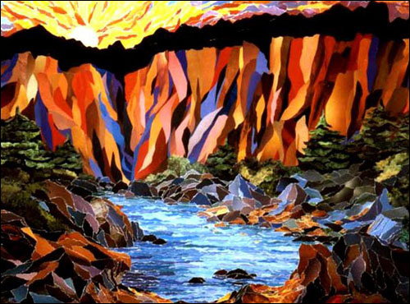

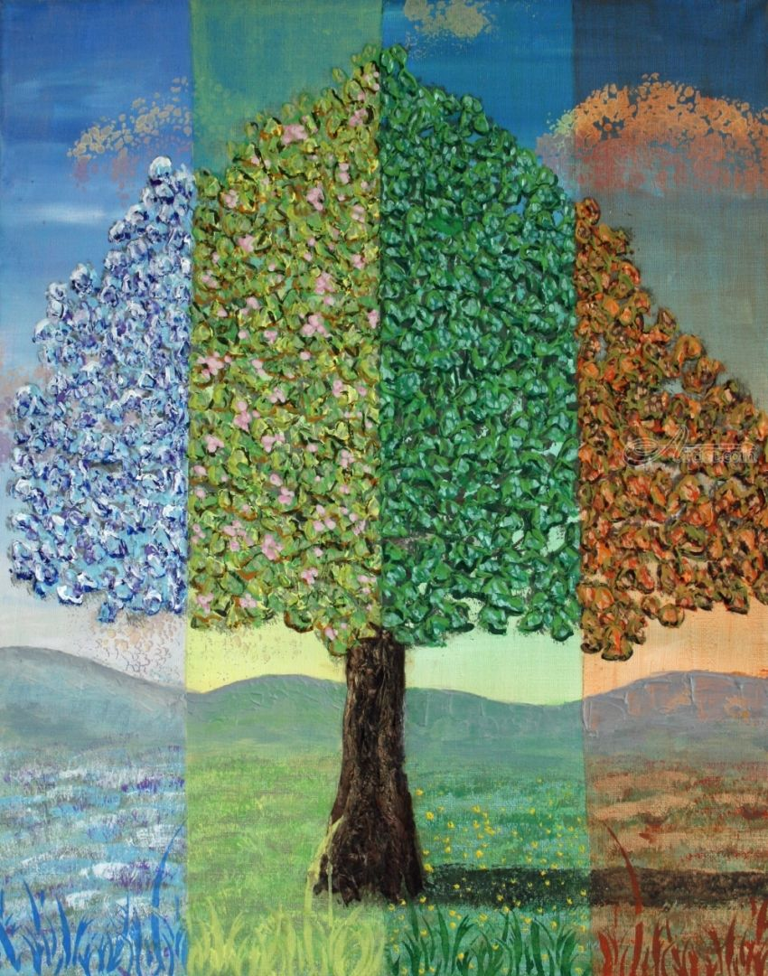

13.4 Students’ artwork examples
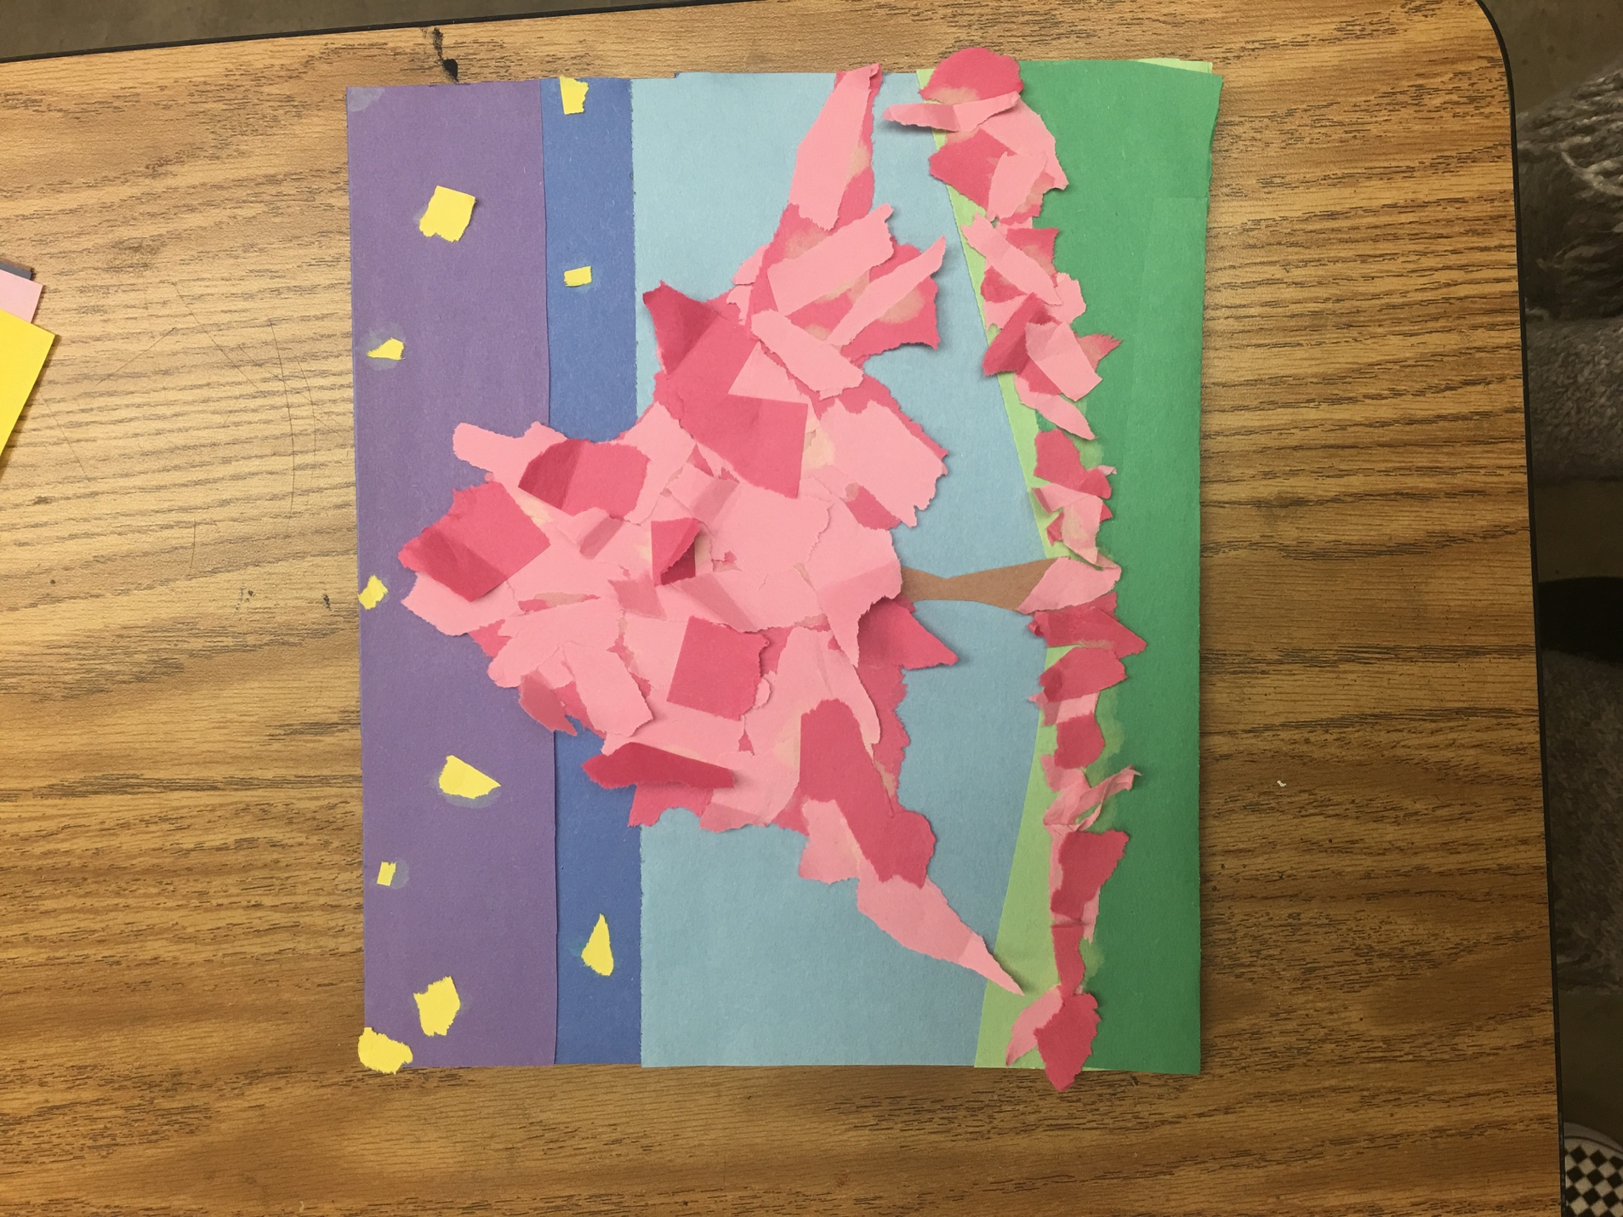
13.5 Class Photos (optional)
- None
13.6 Safety regulations in classroom
- Be aware of at-risk students (students with behavioral issues, mental illnesses or problems that may take advantage of sharp objects). Teacher should collect the scissors from each student if one or more students have any of these issues.

